**MONGODB**

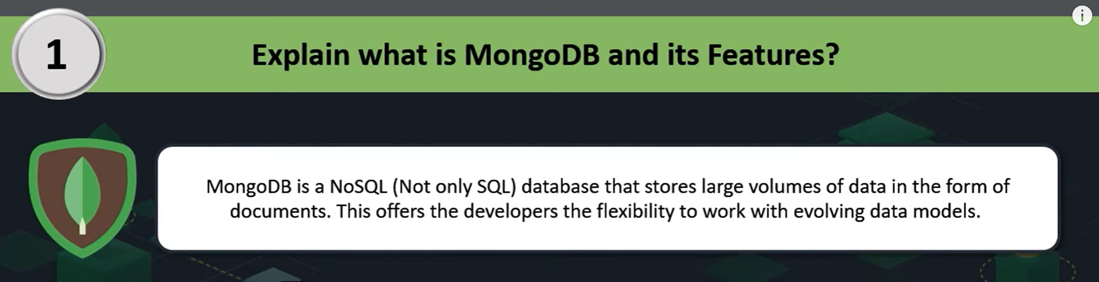

MongoDB is a [NoSQL](https://www.geeksforgeeks.org/introduction-to-nosql/) database, which means it does not use the traditional table-based relational database structure. Instead, it uses a flexible, document-oriented data model that stores data in BSON (Binary JSON) format.

Unlike SQL databases that use rows and columns, MongoDB stores data as [JSON](https://www.geeksforgeeks.org/json/)-like documents, making it easier to handle unstructured data and providing greater flexibility in terms of schema design.

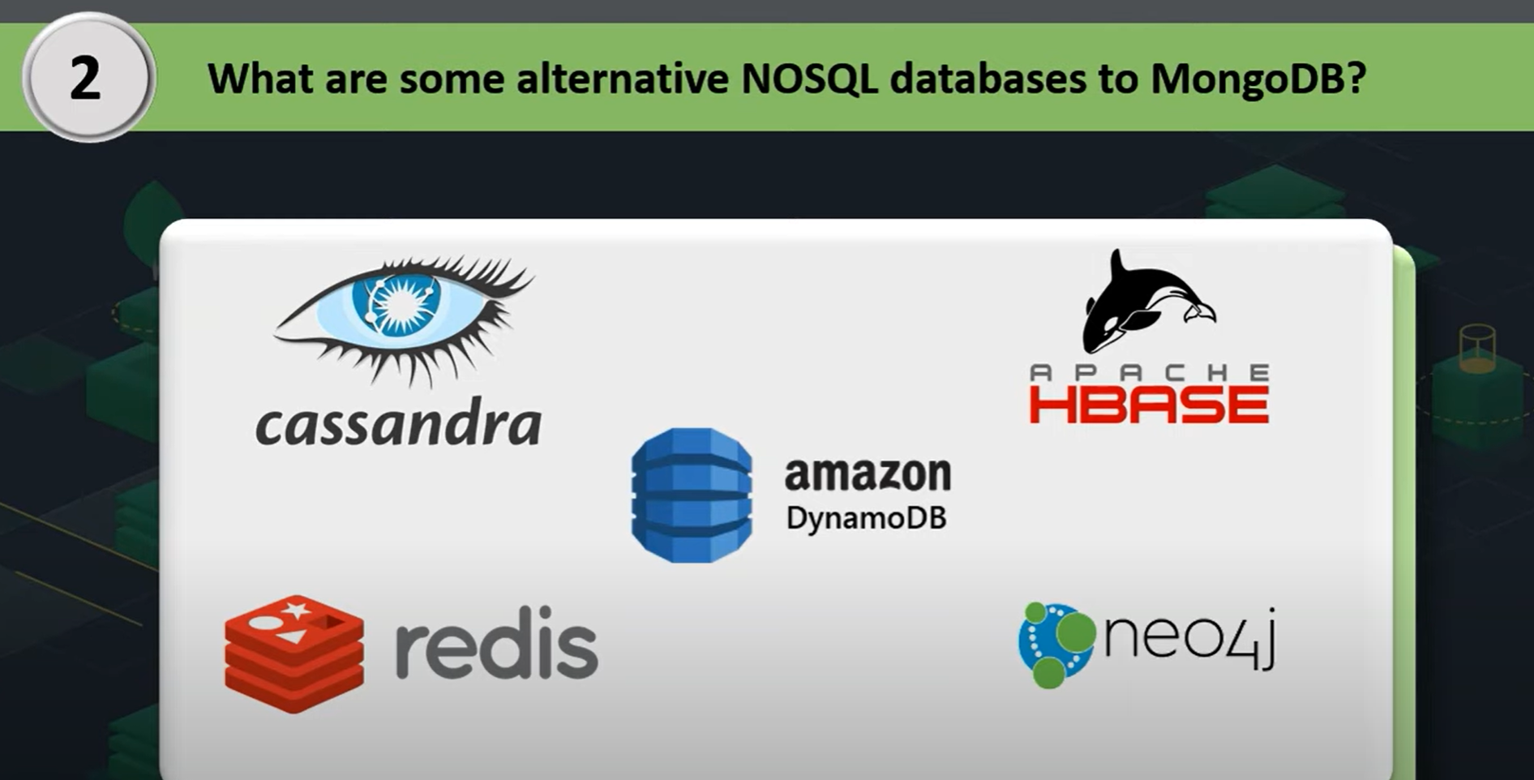

**Explain BSON and Its Significance in MongoDB.**

[BSON](https://www.geeksforgeeks.org/what-is-bson/) (Binary JSON) is a binary-encoded serialization format used by MongoDB to store documents. BSON extends JSON by adding support for data types such as dates and binary data, and it is designed to be efficient in both storage space and scan speed. The binary format allows MongoDB to be more efficient with data retrieval and storage compared to text-based JSON.

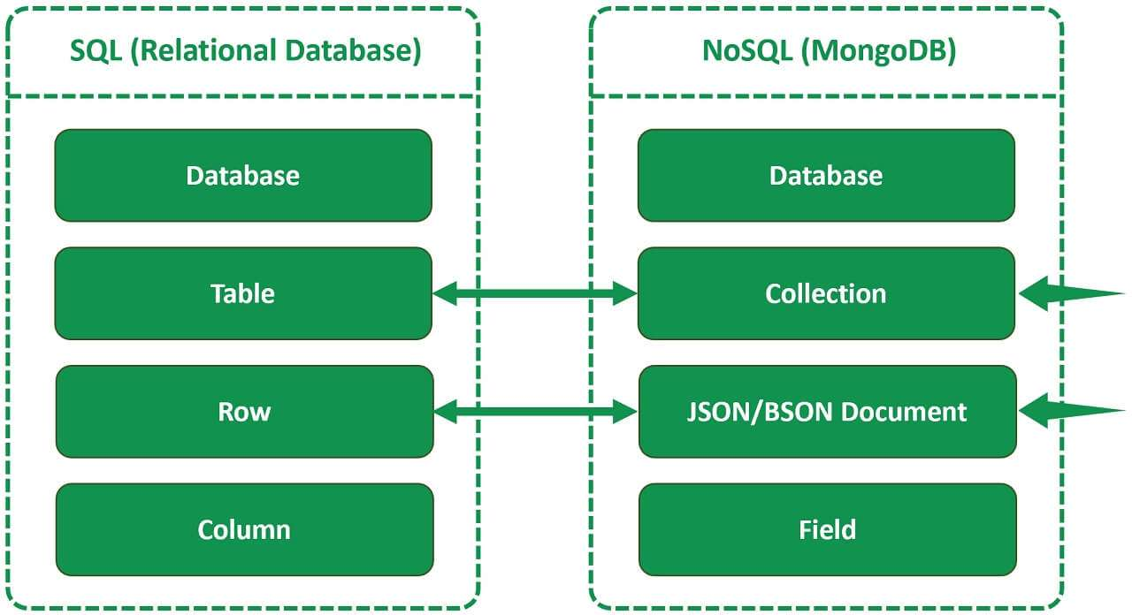

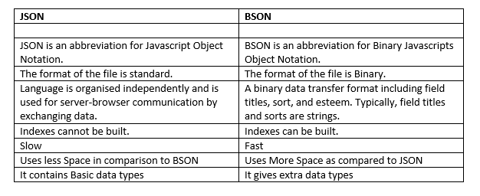

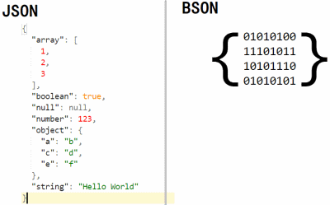

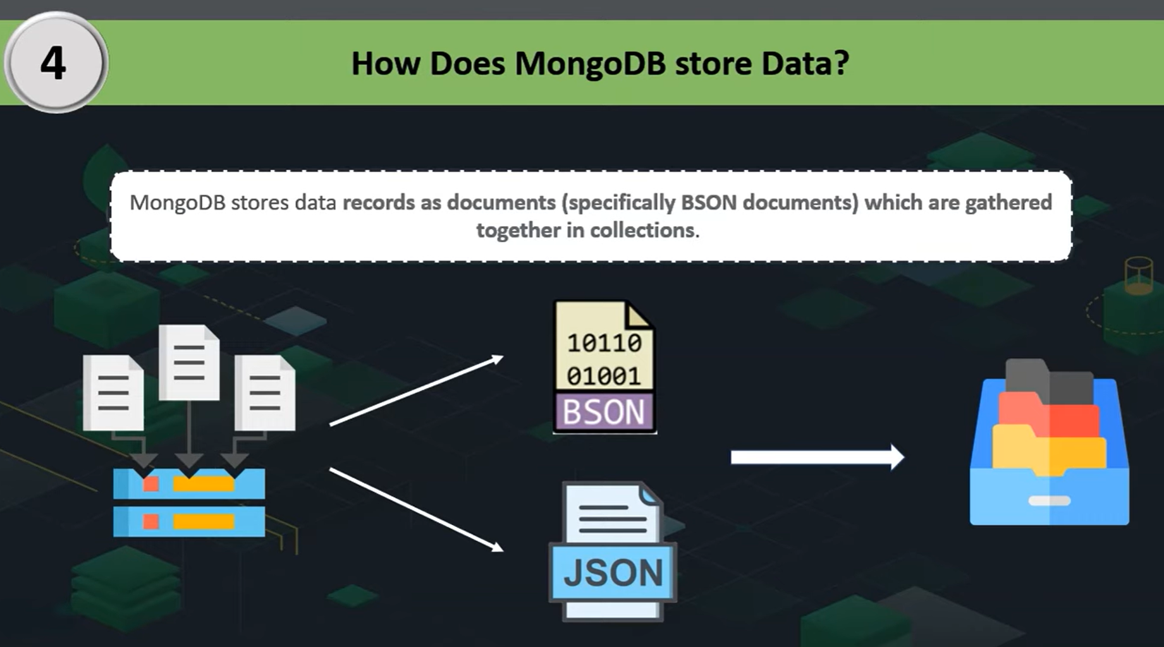



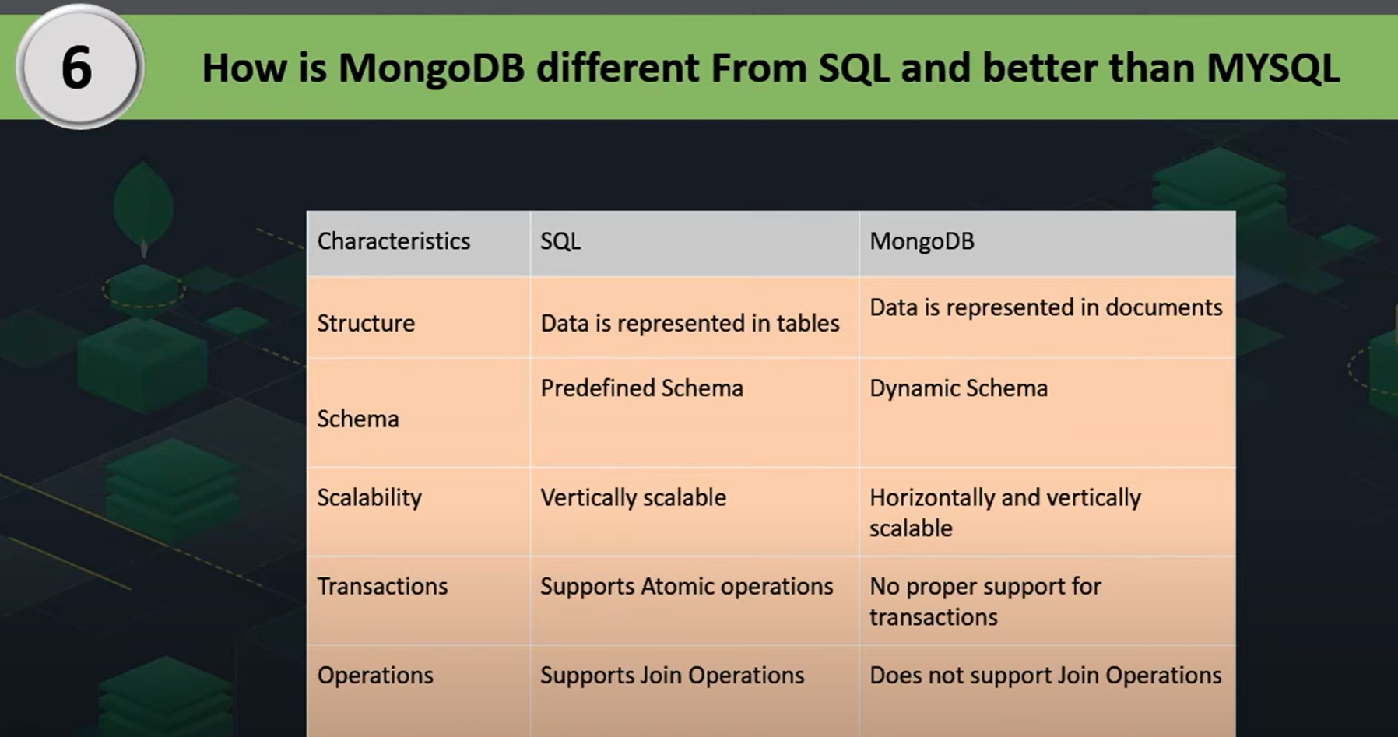

**ATOMIC OPERATION**

It either **completes fully** or **does not happen at all** — there's no in-between state.

Imagine you’re at a bank ATM, and you’re transferring ₹100 from your **Savings** account to your **Checking** account.

You press **"Transfer ₹100"** — here’s what should happen:

1. ₹100 is taken out of **Savings**.
2. ₹100 is added to **Checking**.

Now, think about this:

* What if the ATM removes ₹100 from your **Savings**, but the power goes off before it puts ₹100 into your **Checking**?

That would be a **problem**, right?

**So what does the bank do?**

It uses an **atomic operation**, which means:

**“Either everything happens, or nothing happens at all.”**

So, in our case:

* If the money **can't** be added to your **Checking**, it will **not** take it from **Savings** either.
* If **both** parts can be done, then it proceeds.

**In a database:**

It’s the same idea. When a computer is saving or updating important data (like money, inventory, etc.), it must make sure:

* The full change happens, **or**
* **No change at all**

**What are Collections And Databases In MongoDB?**

In MongoDB, a database is a container for collections, and a collection is a group of MongoDB documents. Collections are equivalent to tables in [SQL](https://www.geeksforgeeks.org/sql-tutorial/) databases, but they do not enforce a schema, allowing for flexibility in the structure of the documents they contain. For example, you might have a users collection in a mydatabase database.

**How Does MongoDB Ensure High Availability and Scalability?**

MongoDB ensures high availability and scalability through its features like replica sets and sharding. Replica sets provide redundancy and failover capabilities, ensuring that data is always available. Sharding distributes data across multiple servers, enabling horizontal scalability to handle large volumes of data and high traffic loads.

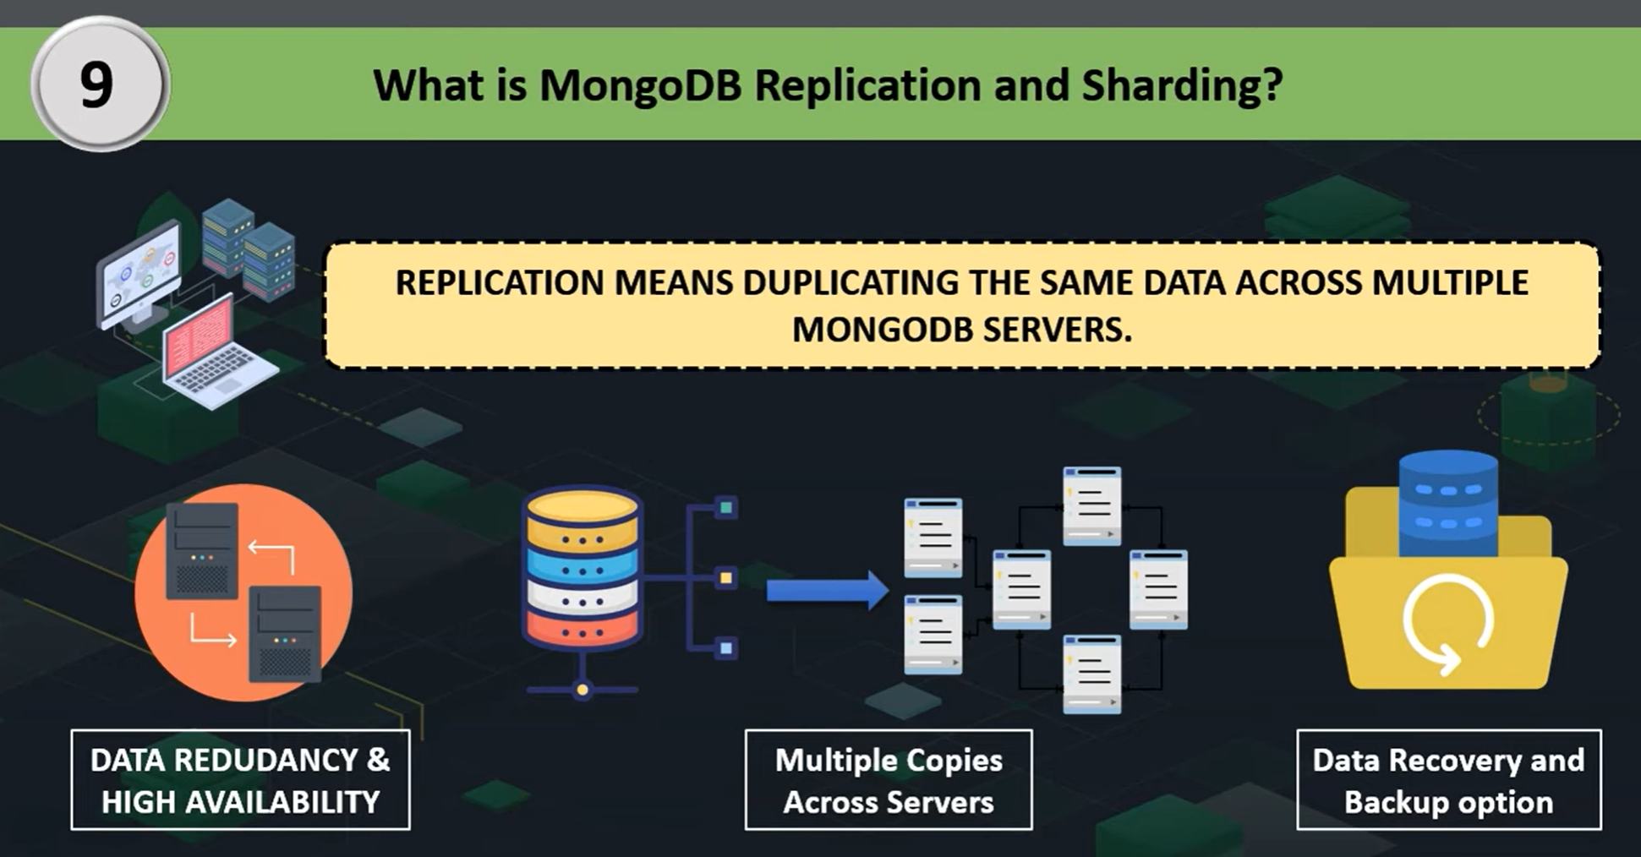

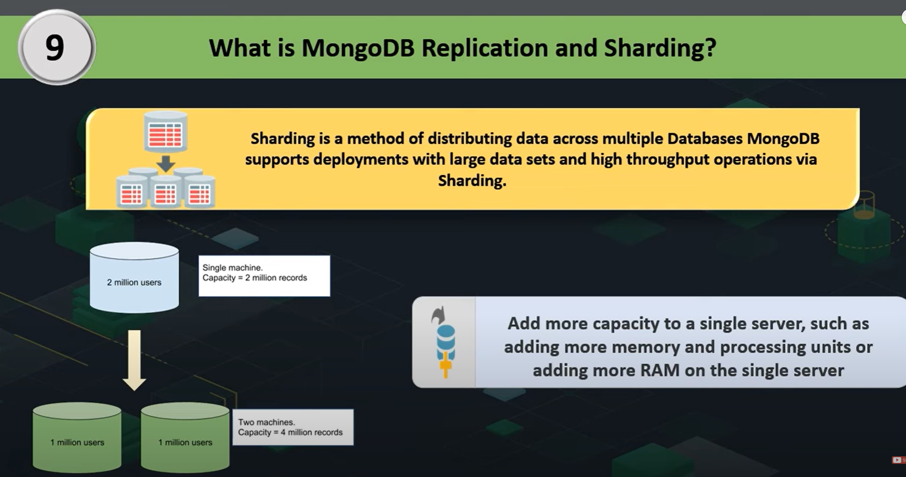

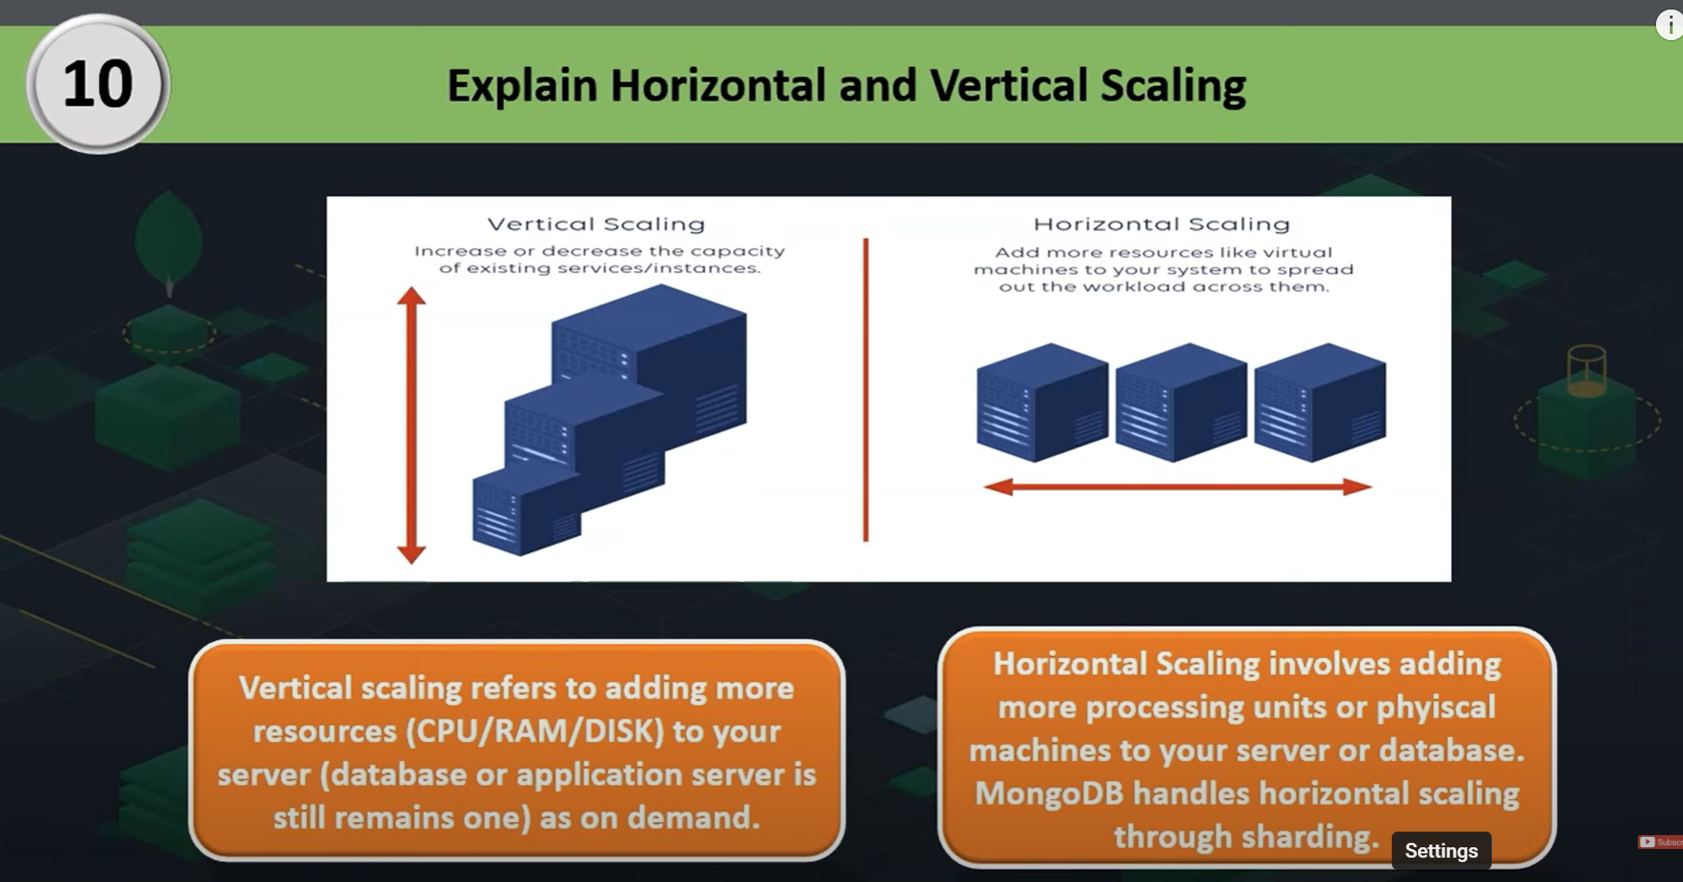

**Think of a Birthday Cake**

You have a huge cake, and you want to **serve it faster** to a room full of people.

Instead of one person cutting and serving the whole cake, you cut the cake into **smaller pieces** (called "shards") and give each piece to a different server (or helper) to handle.

Each server is responsible for **just a part of the data**, not the whole thing. That makes everything **faster**, **easier to manage**, and **scalable**.

**📦 In MongoDB Terms:**

* **Sharding** means splitting a **large collection of data** into **smaller parts**, and storing them across **multiple machines**.
* Each part is called a **shard**.
* MongoDB decides which data goes where using a **shard key** (a field you choose, like user ID or region).

**🛒 Example: Online Shopping App**

Let’s say you have customer data like:

* India customers
* US customers
* UK customers

MongoDB can **shard** this data based on country, so:

* **Shard 1** handles India customers
* **Shard 2** handles US customers
* **Shard 3** handles UK customers

Now, the system is faster and can support **millions** of users easily.

**✅ Benefits of Sharding:**

* Handles **big data** efficiently
* Improves **performance**
* Adds **scalability** (you can keep adding more shards/machines)
* Prevents one server from becoming a **bottleneck**

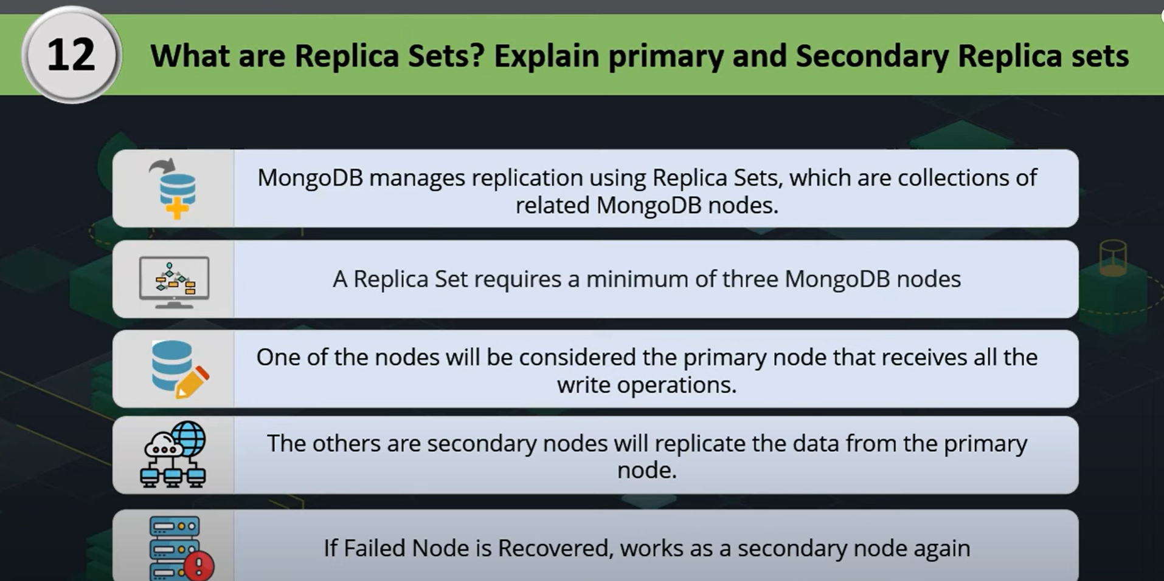

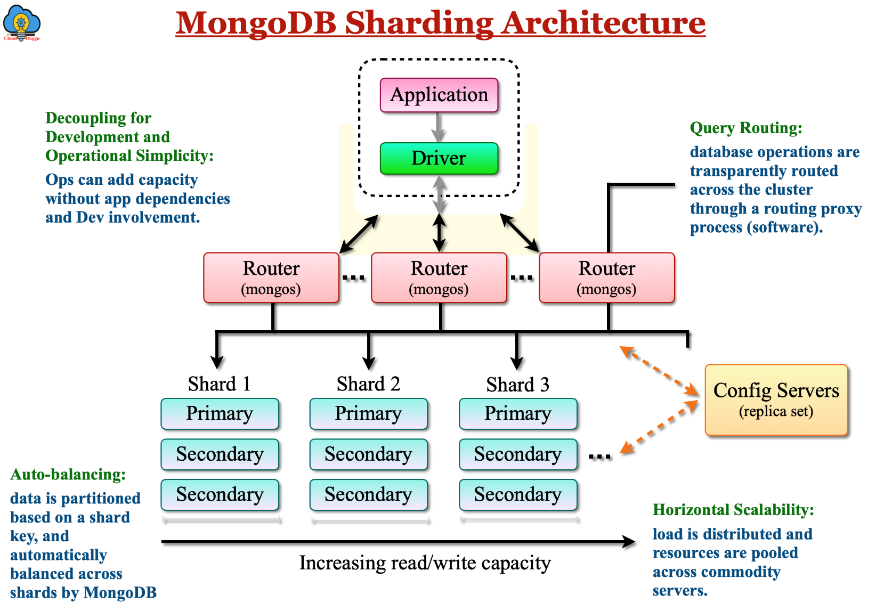

**Replica Sets**

**Imagine you’re running a restaurant, and you keep all your orders written in one notebook. If that notebook gets lost or damaged — you’re in trouble!**

**So, to be safe, you make 2 extra copies of that notebook and keep them with trusted staff. That way, even if one notebook is lost, you still have the same information in the others.**

**💾 In MongoDB Terms:**

**A replica set is a group of MongoDB servers that keep copies of the same data — just like your notebook copies.**

* **The main server is called the Primary — it handles all reads and writes (like taking new orders).**
* **The backup servers are called Secondaries — they keep a real-time copy of the Primary's data.**

**If the Primary server fails or goes down, one of the Secondaries automatically takes over and becomes the new Primary — so your app never stops working.**

**🛡️ Why Replica Sets Are Important:**

* **✅ High Availability – If one server fails, another takes over.**
* **✅ Data Safety – Your data is stored in multiple places.**
* **✅ Read Scaling – You can read data from secondaries to reduce pressure on the primary.**

**7. What are the Advantages of Using MongoDB Over Other Databases?**

* Flexibility: MongoDB’s document-oriented model allows for dynamic schemas.
* Scalability: Built-in sharding enables horizontal scaling.
* High Availability: Replica sets provide redundancy and automatic failover.
* Performance: Efficient storage and retrieval with BSON format.
* Ease of Use: JSON-like documents make it easier for developers to interact with data.

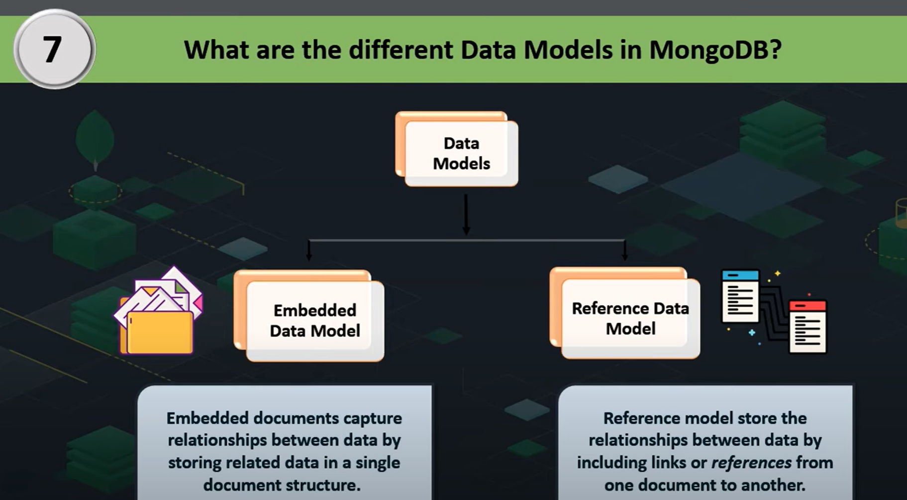

**What is GridFS, and When is it Used in MongoDB?**

GridFS is a specification for storing and retrieving large files in MongoDB. It is used when files exceed the BSON-document size limit of 16 MB or when you need to perform efficient retrieval of specific file sections. GridFS splits a large file into smaller chunks and stores each chunk as a separate document within two collections: fs.files and fs.chunks. This allows for efficient storage and retrieval of large files, such as images, videos, or large datasets.

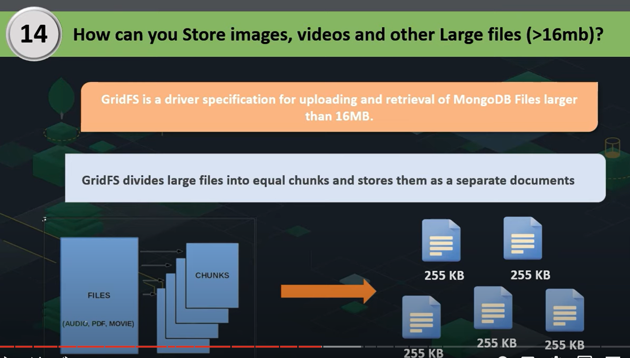

**Explain the Differences Between WiredTiger and MMAPv1 Storage Engines**

WiredTiger and MMAPv1 are two different storage engines in MongoDB, each with distinct characteristics:

**WiredTiger:**

* Concurrency: Provides document-level concurrency, allowing multiple operations to be performed simultaneously.
* Compression: Supports data compression, reducing storage space requirements.
* Performance: Generally offers better performance and efficiency for most workloads.
* Journaling: Uses a write-ahead logging mechanism for better data integrity.

**MMAPv1:**

* Concurrency: Provides collection-level concurrency, which can limit performance under heavy write operations.
* No Compression: Does not support data compression.
* Legacy Engine: It is the older storage engine and has been deprecated in favor of WiredTiger.
* Simplicity: Simple implementation but lacks advanced features compared to WiredTiger.

**How to Handle Transactions in MongoDB?**

MongoDB supports multi-document ACID transactions, allowing you to perform a series of read and write operations across multiple documents and collections in a transaction. This ensures data consistency and integrity. To use transactions, you typically start a session, begin a transaction, perform the operations, and then commit or abort the transaction.

**Example in JavaScript:**

const session = client.startSession();  
  
session.startTransaction();  
  
try {  
 db.collection1.insertOne({ name: "Alice" }, { session });  
 db.collection2.insertOne({ name: "Bob" }, { session });  
 session.commitTransaction();  
} catch (error) {  
 session.abortTransaction();  
} finally {  
 session.endSession();  
}

**What is MongoDB Atlas, and How Does it Differ From Self-Hosted MongoDB?**

MongoDB Atlas is a fully managed cloud database service provided by MongoDB. It offers automated deployment, scaling, and management of MongoDB clusters across various cloud providers ([AWS](https://www.geeksforgeeks.org/aws-tutorial/), [Azure](https://www.geeksforgeeks.org/microsoft-azure/), [Google Cloud](https://www.geeksforgeeks.org/google-cloud-platform-tutorial/)). Key differences from self-hosted MongoDB include:

* Managed Service: Atlas handles infrastructure management, backups, monitoring, and upgrades.
* Scalability: Easily scale clusters up or down based on demand.
* Security: Built-in security features such as encryption, access controls, and compliance certifications.
* Global Distribution: Deploy clusters across multiple regions for low-latency access and high availability.
* Integrations: Seamless integration with other cloud services and MongoDB tools.

**What are Capped Collections, and When are They Useful?**

Capped collections in MongoDB are fixed-size collections that automatically overwrite the oldest documents when the specified size limit is reached. They maintain insertion order and are useful for scenarios where you need to store a fixed amount of recent data, such as logging, caching, or monitoring data.

Example of creating a capped collection:

db.createCollection("logs", { capped: true, size: 100000 });

**Explain the Concept of Geospatial Indexes in MongoDB**

Geospatial indexes in MongoDB are special indexes that support querying of geospatial data, such as locations and coordinates. They enable efficient queries for proximity, intersections, and other spatial relationships. MongoDB supports two types of geospatial indexes: 2d for flat geometries and 2dsphere for spherical geometries.

Example of creating a 2dsphere index:

db.places.createIndex({ location: "2dsphere" });



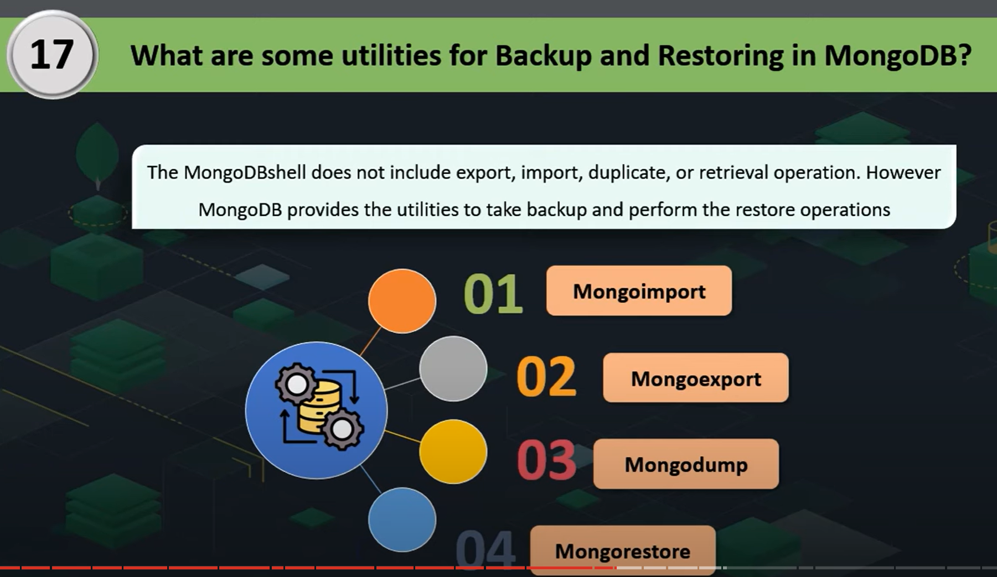

**How to Handle Backups and Disaster Recovery in MongoDB?**

Handling backups and disaster recovery in MongoDB involves regularly creating backups of your data and having a plan for restoring data in case of failure. Methods include:

* Mongodump/Mongorestore: Use the mongodump and mongorestore utilities to create and restore binary backups.
* File System Snapshots: Use file system snapshots to take consistent backups of the data files.
* Cloud Backups: If using MongoDB Atlas, leverage automated backups provided by the service.
* Replica Sets: Use replica sets to ensure data redundancy and high availability. Regularly test the failover and recovery process.

**What are Change Streams in MongoDB, and How are They Used?**

Change Streams in MongoDB allow applications to listen for real-time changes to data in collections, databases, or entire clusters. They provide a powerful way to implement event-driven architectures by capturing insert, update, replace, and delete operations. To use Change Streams, you typically open a change stream cursor and process the change events as they occur.

**Example:**

const changeStream = db.collection('orders').watch();  
changeStream.on('change', (change) => {  
 console.log(change);  
});

This example listens for changes in the orders collection and logs the change events.

**Explain the Use of Hashed Sharding Keys in MongoDB**

Hashed Sharding Keys in MongoDB distribute data across shards using a hashed value of the shard key field. This approach ensures an even distribution of data and avoids issues related to data locality or uneven data distribution that can occur with range-based sharding. Hashed sharding is useful for fields with monotonically increasing values, such as timestamps or identifiers.

**Example:**

db.collection.createIndex({ _id: "hashed" });  
sh.shardCollection("mydb.mycollection", { _id: "hashed" });

**33. How to Optimize MongoDB Queries for Performance?**

Optimizing MongoDB queries involves several strategies:

* **Indexes:** Create appropriate indexes to support query patterns.
* **Query Projections:** Use projections to return only necessary fields.
* **Index Hinting:**Use index hints to force the query optimizer to use a specific index.
* **Query Analysis:** Use the explain() method to analyze query execution plans and identify bottlenecks.
* **Aggregation Pipeline:** Optimize the aggregation pipeline stages to minimize data processing and improve efficiency.

**What is the Role of Journaling in MongoDB, and How Does It Impact Performance?**

**📓 What is Journaling in MongoDB? (Simple, Non-Technical Explanation)**

Let’s say you’re writing an **important school essay** on your computer. Every time you type a sentence, you **don’t want to lose your work** if the power goes off suddenly.

So, your writing app saves a **backup copy** of your changes in a side file every few seconds — that way, if your computer crashes, it can **recover your work** from that backup file.

**💾 In MongoDB Terms:**

**Journaling** is that **backup safety mechanism**.

MongoDB uses journaling to:

* Record every change it makes (like inserts, updates, deletes)
* Save those changes in a **journal file** before applying them to the actual database files

So, if MongoDB crashes suddenly (due to power failure, hardware issue, etc.), it can **recover all recent changes** using the **journal file**.

.

**🔐 Why Journaling is Important:**

* ✅ **Crash Recovery** – MongoDB can restore data safely after an unexpected shutdown
* ✅ **Data Integrity** – Prevents data corruption
* ✅ **Peace of Mind** – Helps you trust that your recent data changes won’t get lost

**36. How to Implement Full-Text Search in MongoDB?**

Full-Text Search in MongoDB is implemented using text indexes. These indexes allow you to perform text search queries on string content within documents.

**Example:**

db.collection.createIndex({ content: "text" });  
db.collection.find({ $text: { $search: "mongodb" } });

In this example, a text index is created on the content field, and a text search query is performed to find documents containing the word “mongodb.”

**What is an Index in MongoDB?**

Imagine you're reading a **big book**, and you want to find every page that mentions **"React"**. If the book has an **index at the back**, you can find the page numbers instantly.

Without an index, you’d have to flip through **every page** — which is **slow and time-consuming**.

**📂 In MongoDB Terms:**

An **index** helps MongoDB **find data faster** — instead of scanning every document in a collection, it jumps directly to the data using the index.

So:

* Without index = **slow search**
* With index = **fast search**

db.users.createIndex({ email: 1 }) // 1 means ascending order

📌 2. Using Mongoose in Node.js:

const userSchema = new mongoose.Schema({

name: String,

email: { type: String, index: true }, // adds index to email

age: Number

});

**✅ Benefits:**

* Faster queries
* Better performance
* Required for some features (e.g., unique fields)

**⚠️ But:**

* Indexes use extra space
* Too many indexes can slow down **writes** (insert/update/delete)

**Explain the Concept of Horizontal Scalability and Its Implementation in MongoDB**

Horizontal Scalability in MongoDB refers to the ability to add more servers to distribute the load and data. This is achieved through sharding, where data is partitioned across multiple shards. Each shard is a replica set that holds a subset of the data. Sharding allows MongoDB to handle large datasets and high-throughput operations by distributing the workload.

**39. How to Monitor and Troubleshoot Performance Issues in MongoDB?**

**Use MongoDB's Built-in Monitoring Tools**

**a. db.currentOp()**

Shows running operations. Helps find slow or stuck queries.

db.currentOp()

**b. db.serverStatus()**

Gives detailed performance stats like:

* CPU usage
* Memory
* Connections
* Locks

db.serverStatus()

**c. db.stats()**

Shows collection-level statistics (size, count, storage, etc.)

**✅ 2. Use the MongoDB Atlas Monitoring Dashboard (if you're using Atlas)**

* Live charts for **CPU**, **RAM**, **Disk I/O**, **slow queries**
* Alerts and notifications
* Query performance analytics (like which queries are slow)

**✅ 3. Analyze and Optimize Slow Queries**

**a. Enable the Slow Query Log**

MongoDB logs queries that exceed a certain time.

db.setProfilingLevel(1, { slowms: 100 }) // logs queries slower than 100ms

**b. Use explain() to Analyze Queries**

db.users.find({ email: "roy@example.com" }).explain("executionStats")

Look at:

* nReturned: number of documents returned
* totalKeysExamined: how many index entries it checked
* totalDocsExamined: how many full documents were scanned (should be low)

**✅ 4. Check Index Usage**

Use:

db.collection.getIndexes()

db.collection.explain().find({ field: "value" })

If MongoDB is scanning **all documents**, you need to **add an index** on that field.

**✅ 5. Use External Tools (Optional but Useful)**

| **Tool** | **Description** |
| --- | --- |
| **mongotop** | Shows read/write activity by collection |
| **mongostat** | Real-time database stats (insert/sec, query/sec, etc.) |
| **MongoDB Compass** | GUI tool to visualize slow queries, indexes, and more |

**✅ 6. Common Fixes for Performance Issues**

| **Problem** | **Solution** |
| --- | --- |
| Slow queries | Use proper indexes, avoid $regex on big data |
| High memory usage | Optimize indexes, avoid large in-memory queries |
| Locking issues | Use WiredTiger (default), break up large writes |
| Too many open connections | Use connection pooling and close unused ones |
| Unoptimized schema | Normalize or denormalize as needed |

**Describe the Process of Migrating Data from a Relational Database to MongoDB**

Migrating data from a relational database to MongoDB involves several steps:

* Schema Design: Redesign the relational schema to fit MongoDB’s document-oriented model. Decide on embedding vs. referencing, and plan for indexes and collections.
* Data Export: Export data from the relational database in a format suitable for MongoDB (e.g., CSV, JSON).
* Data Transformation: Transform the data to match the MongoDB schema. This can involve converting data types, restructuring documents, and handling relationships.
* Data Import: Import the transformed data into MongoDB using tools like mongoimport or custom scripts.
* Validation: Validate the imported data to ensure consistency and completeness.
* Application Changes: Update the application code to interact with MongoDB instead of the relational database.
* Testing: Thoroughly test the application and the database to ensure everything works as expected.
* Go Live: Deploy the MongoDB database in production and monitor the transition.

// Database Commands

use myDatabase

// Switches to the database myDatabase. If it does not exist, it will be created upon inserting data.

db

// Displays the name of the current database.

show collections

// Lists all collections in the current database.

db.createCollection("myCollection")

// Creates a new collection named myCollection.

db.myCollection.drop()

// Deletes the collection myCollection.

// Document Commands

db.myCollection.insertOne({ name: "Alice", age: 25 })

// Inserts a single document into the collection myCollection.

db.myCollection.insertMany([{ name: "Bob", age: 30 }, { name: "Carol", age: 27 }])

// Inserts multiple documents into the collection myCollection.

db.myCollection.find()

// Retrieves and displays all documents from the collection myCollection.

db.myCollection.find({ age: { $gte: 25 } })

// Retrieves documents from myCollection where the age is greater than or equal to 25.

db.myCollection.findOne({ name: "Alice" })

// Retrieves the first document from myCollection where the name is "Alice".

db.myCollection.updateOne({ name: "Alice" }, { $set: { age: 26 } })

// Updates the age to 26 for the first document in myCollection where the name is "Alice".

db.myCollection.updateMany({ age: { $lt: 30 } }, { $set: { status: "young" } })

// Adds a "status" field with value "young" to all documents in myCollection where the age is less than 30.

db.myCollection.replaceOne({ name: "Alice" }, { name: "Roy", age: 26, status: "young" })

// Replaces the first document in myCollection where the name is "Alice" with a new document.

db.myCollection.deleteOne({ name: "Alice" })

// Deletes the first document in myCollection where the name is "Alice".

db.myCollection.deleteMany({ status: "young" })

// Deletes all documents in myCollection where the status is "young".

//--------------------------------Operators in MongoDB-----------------------------------

1. $eq (Equal)

// Matches documents where the value of a field is equal to the specified value.

db.myCollection.find({ age: { $eq: 30 } })

// Finds documents where the age field is equal to 30.

// Example output:

// { "_id": ObjectId("..."), "name": "Bob", "age": 30 }

2. $ne (Not Equal)

// Matches documents where the value of a field is not equal to the specified value.

db.myCollection.find({ age: { $ne: 30 } })

// Example output:

// [

//   { "_id": ObjectId("..."), "name": "Alice", "age": 25 },

//   { "_id": ObjectId("..."), "name": "Charlie", "age": 35 },

//   { "_id": ObjectId("..."), "name": "David", "age": 40 }

// ]

3. $gt (Greater Than)

// Matches documents where the value of a field is greater than the specified value.

db.myCollection.find({ age: { $gt: 30 } })

// Example output:

// [

//   { "_id": ObjectId("..."), "name": "Charlie", "age": 35 },

//   { "_id": ObjectId("..."), "name": "David", "age": 40 }

// ]

4. $gte (Greater Than or Equal To)

// Matches documents where the value of a field is greater than or equal to the specified value.

db.myCollection.find({ age: { $gte: 30 } })

// Example output:

// [

//   { "_id": ObjectId("..."), "name": "Bob", "age": 30 },

//   { "_id": ObjectId("..."), "name": "Charlie", "age": 35 },

//   { "_id": ObjectId("..."), "name": "David", "age": 40 }

// ]

5. $lt (Less Than)

// Matches documents where the value of a field is less than the specified value.

db.myCollection.find({ age: { $lt: 30 } })

// Example output:

// { "_id": ObjectId("..."), "name": "Alice", "age": 25 }

6. $lte (Less Than or Equal To)

// Matches documents where the value of a field is less than or equal to the specified value.

db.myCollection.find({ age: { $lte: 30 } })

// Example output:

// [

//   { "_id": ObjectId("..."), "name": "Alice", "age": 25 },

//   { "_id": ObjectId("..."), "name": "Bob", "age": 30 }

// ]

7. $in (In) // Matches any value in an array

// Matches documents where the value of a field equals any value in the specified array.

db.myCollection.find({ age: { $in: [25, 35] } })

// Example output:

// [

//   { "_id": ObjectId("..."), "name": "Alice", "age": 25 },

//   { "_id": ObjectId("..."), "name": "Charlie", "age": 35 }

// ]

8. $nin (Not In) // Does not match any value in an array

// Matches documents where the value of a field does not equal any value in the specified array.

db.myCollection.find({ age: { $nin: [25, 35] } })

// Example output:

// [

//   { "_id": ObjectId("..."), "name": "Bob", "age": 30 },

//   { "_id": ObjectId("..."), "name": "David", "age": 40 }

// ]

**What are TTL Indexes, and How are They Used in MongoDB?**

TTL (Time To Live) Indexes in MongoDB are special indexes that automatically remove documents from a collection after a certain period. They are commonly used for data that needs to expire after a specific time, such as session information, logs, or temporary data. To create a TTL index, you can specify the expiration time in seconds:

db.sessions.createIndex({ "createdAt": 1 }, { expireAfterSeconds: 3600 })

This index will remove documents from the sessions collection 1 hour (3600 seconds) after the createdAt field’s value.

**Describe the Aggregation Framework in MongoDB**

An **Aggregation Pipeline** in MongoDB is a **step-by-step data processing tool** that allows you to **transform, filter, group, and analyze** documents in a collection — just like assembling parts on a factory line.

Each step in the pipeline is called a **stage**, and each stage takes in documents, performs an operation, and passes the results to the next stage.

**🔧 Real-World Analogy:**

Think of it like a **juice factory**:

1. 🍊 Pick oranges → ($match)
2. 🧼 Wash them → ($project)
3. 🥤 Squeeze and bottle → ($group)
4. 📦 Pack by size → ($sort, $limit)

db.orders.aggregate([

  { $match: { status: "completed" } },        // Stage 1: Filter

  { $group: { _id: "$custId", total: { $sum: "$amount" } } },// Stage 2: Group by customer

  { $sort: { total: -1 } }                    // Stage 3: Sort by total

])

**Common Aggregation Pipeline Stages**

1. **$match**:
   * Filters documents by a specified condition, similar to the find method.
   * Example: Filter documents where the age is greater than 30.

{

$match: { age: { $gt: 30 } }

}

1. **$group**:
   * Groups documents by a specified key and can apply aggregate functions like sum, avg, min, max, etc.
   * Example: Group documents by department and calculate the total salary.

{

$group: { _id: "$department", totalSalary: { $sum: "$salary" } }

}

1. **$project**:
   * Shapes the documents by including, excluding, or adding new fields. It's similar to select in SQL.
   * Example: Include the name field and a computed field totalPrice (price * quantity).

{

$project: { name: 1, totalPrice: { $multiply: ["$price", "$quantity"] } }

}

1. **$sort**:
   * Sorts the documents based on a specified field in ascending or descending order.
   * Example: Sort documents by createdAt in descending order.

{

$sort: { createdAt: -1 }

}

1. **$limit**:
   * Limits the number of documents in the output.
   * Example: Limit to the first 5 documents.

{

$limit: 5

}

1. **$skip**:
   * Skips a specified number of documents, often used for pagination.
   * Example: Skip the first 10 documents.

{

$skip: 10

}

1. **$unwind**:
   * Deconstructs an array field into multiple documents, one per element.
   * Example: Unwind an array of tags, creating a new document for each tag.

{

$unwind: "$tags"

}

1. **$lookup**:
   * Performs a left outer join with another collection, similar to SQL joins.
   * Example: Join the orders collection with the customers collection using customerId.

{

$lookup: {

from: "customers",

localField: "customerId",

foreignField: "_id",

as: "customerDetails"

}

}

1. **$addFields**:
   * Adds or modifies fields in the documents.
   * Example: Add a new field fullName that concatenates the first and last name.

{

$addFields: { fullName: { $concat: ["$firstName", " ", "$lastName"] } }

}

1. **$out**:
   * Writes the output of the aggregation pipeline to a new collection.
   * Example: Write the results to a collection named summary.

{

$out: "summary"

}

1. **$replaceRoot / $replaceWith**:
   * Replaces the root document with a specified document.
   * Example: Replace the root document with the embedded address field.

{

$replaceRoot: { newRoot: "$address" }

}

1. **$count**:
   * Counts the number of documents that pass through the pipeline and outputs the count.
   * Example: Count the total number of documents.

{

$count: "totalDocuments"

}

1. **$facet**:
   * Allows running multiple aggregation pipelines within a single stage, returning multiple outputs in parallel.
   * Example: Return total count and list of documents in two separate pipelines.

{

$facet: {

totalDocs: [{ $count: "count" }],

docs: [{ $skip: 0 }, { $limit: 10 }]

}

}

1. **$merge**:
   * Merges the results of the pipeline into an existing collection.
   * Example: Merge the pipeline results into a summary collection.

{

$merge: { into: "summary", whenMatched: "merge", whenNotMatched: "insert" }

}

1. **$sample**:
   * Randomly selects a specified number of documents.
   * Example: Select a random sample of 5 documents.

{

$sample: { size: 5 }

}

1. **$redact**:
   * Filters document fields based on access control rules or other conditions.
   * Example: Conditionally include or exclude certain fields from the output.

{

$redact: {

$cond: {

if: { $eq: ["$secret", true] },

then: "$$PRUNE",

else: "$$KEEP"

}

}

}

1. **$set**:
   * Adds new fields to the documents, equivalent to $addFields.
   * Example: Set a new field status with a value of "active".

{

$set: { status: "active" }

}

1. **$bucket**:
   * Categorizes documents into buckets based on a specified field.
   * Example: Bucket documents based on age into age groups.

{

$bucket: {

groupBy: "$age",

boundaries: [0, 18, 30, 50, 80],

default: "Other",

output: { count: { $sum: 1 } }

}

}

1. **$bucketAuto**:
   * Automatically categorizes documents into a specified number of buckets based on an evenly distributed value range.
   * Example: Auto-bucket documents into 5 groups based on the price field.

{

$bucketAuto: {

groupBy: "$price",

buckets: 5,

output: { count: { $sum: 1 } }

}

}

**Example Pipeline:**

Here’s a simple aggregation pipeline example that filters, groups, and sorts of documents:

db.orders.aggregate([

{ $match: { status: "completed" } }, // Filter by completed status

{ $group: { _id: "$customerId", totalSpent: { $sum: "$totalAmount" } } }, // Group by customer and sum the total amount

{ $sort: { totalSpent: -1 } }, // Sort by total spent in descending order

{ $limit: 10 } // Limit to the top 10 customers

]);

**Conclusion**

**MongoDB Query Based Interview Questions**

MongoDB Query-Based Interview Questions focus on your ability to write and optimize queries to interact with the database effectively. These questions typically include tasks like retrieving specific data using filters, sorting and paginating results, and using projection to select fields.

"[  
 {  
 ""_id"": 1,  
 ""name"": ""John Doe"",  
 ""age"": 28,  
 ""position"": ""Software Engineer"",  
 ""salary"": 80000,  
 ""department"": ""Engineering"",  
 ""hire_date"": ISODate(""2021-01-15"")  
 },  
 {  
 ""_id"": 2,  
 ""name"": ""Jane Smith"",  
 ""age"": 34,  
 ""position"": ""Project Manager"",  
 ""salary"": 95000,  
 ""department"": ""Engineering"",  
 ""hire_date"": ISODate(""2019-06-23"")  
 },  
 {  
 ""_id"": 3,  
 ""name"": ""Emily Johnson"",  
 ""age"": 41,  
 ""position"": ""CTO"",  
 ""salary"": 150000,  
 ""department"": ""Management"",  
 ""hire_date"": ISODate(""2015-03-12"")  
 },  
 {  
 ""_id"": 4,  
 ""name"": ""Michael Brown"",  
 ""age"": 29,  
 ""position"": ""Software Engineer"",  
 ""salary"": 85000,  
 ""department"": ""Engineering"",  
 ""hire_date"": ISODate(""2020-07-30"")  
 },  
 {  
 ""_id"": 5,  
 ""name"": ""Sarah Davis"",  
 ""age"": 26,  
 ""position"": ""UI/UX Designer"",  
 ""salary"": 70000,  
 ""department"": ""Design"",  
 ""hire_date"": ISODate(""2022-10-12"")  
 }  
]"

**1. Find all Employees Who Work in the “Engineering” Department.**

**Query:**

db.employees.find({ department: "Engineering" })

**Output:**

[  
 {  
 "_id": 1,  
 "name": "John Doe",  
 "age": 28,  
 "position": "Software Engineer",  
 "salary": 80000,  
 "department": "Engineering",  
 "hire_date": ISODate("2021-01-15")  
 },  
 {  
 "_id": 2,  
 "name": "Jane Smith",  
 "age": 34,  
 "position": "Project Manager",  
 "salary": 95000,  
 "department": "Engineering",  
 "hire_date": ISODate("2019-06-23")  
 },  
 {  
 "_id": 4,  
 "name": "Michael Brown",  
 "age": 29,  
 "position": "Software Engineer",  
 "salary": 85000,  
 "department": "Engineering",  
 "hire_date": ISODate("2020-07-30")  
 }  
]

**Explanation:**

This query finds all employees whose department field is “Engineering”.

**2. Find the Employee with the Highest Salary.**

**Query:**

db.employees.find().sort({ salary: -1 }).limit(1)

**Output:**

[  
 {  
 "_id": 3,  
 "name": "Emily Johnson",  
 "age": 41,  
 "position": "CTO",  
 "salary": 150000,  
 "department": "Management",  
 "hire_date": ISODate("2015-03-12")  
 }  
]

**Explanation:**

This query sorts all employees by salary in descending order and retrieves the top document, which is the employee with the highest salary.

**3. Update the Salary of “John Doe” to 90000.**

**Query:**

db.employees.updateOne({ name: "John Doe" }, { $set: { salary: 90000 } })

**Output:**

{ "acknowledged" : true, "matchedCount" : 1, "modifiedCount" : 1 }

**Explanation:**

This query updates the salary of the employee named “John Doe” to 90000.

**4. Count the Number of Employees in Each Department.**

**Query:**

db.employees.aggregate([  
 { $group: { _id: "$department", count: { $sum: 1 } } }  
])

**Output:**

[  
 { "_id": "Engineering", "count": 3 },  
 { "_id": "Management", "count": 1 },  
 { "_id": "Design", "count": 1 }  
]

**Explanation:**

This query groups the employees by the department field and counts the number of employees in each department.

**5. Add a New Field Bonus to All Employees in the “Engineering” Department with a Value of 5000.**

**Query:**

db.employees.updateMany({ department: "Engineering" }, { $set: { bonus: 5000 } })

**Output:**

{ "acknowledged" : true, "matchedCount" : 3, "modifiedCount" : 3 }

**Explanation:**

This query adds a new field bonus with a value of 5000 to all employees in the “Engineering” department.

**6. Retrieve All Documents in the Employees Collection and Sort Them by the Length of Their Name in Descending Order.**

**Query:**

db.employees.aggregate([  
 { $addFields: { nameLength: { $strLenCP: "$name" } } },  
 { $sort: { nameLength: -1 } },  
 { $project: { nameLength: 0 } }  
])

**Output:**

[  
 {  
 "_id": 2,  
 "name": "Jane Smith",  
 "age": 34,  
 "position": "Project Manager",  
 "salary": 95000,  
 "department": "Engineering",  
 "hire_date": ISODate("2019-06-23")  
 },  
 {  
 "_id": 3,  
 "name": "Emily Johnson",  
 "age": 41,  
 "position": "CTO",  
 "salary": 150000,  
 "department": "Management",  
 "hire_date": ISODate("2015-03-12")  
 },  
 {  
 "_id": 1,  
 "name": "John Doe",  
 "age": 28,  
 "position": "Software Engineer",  
 "salary": 80000,  
 "department": "Engineering",  
 "hire_date": ISODate("2021-01-15")  
 },  
 {  
 "_id": 4,  
 "name": "Michael Brown",  
 "age": 29,  
 "position": "Software Engineer",  
 "salary": 85000,  
 "department": "Engineering",  
 "hire_date": ISODate("2020-07-30")  
 },  
 {  
 "_id": 5,  
 "name": "Sarah Davis",  
 "age": 26,  
 "position": "UI/UX Designer",  
 "salary": 70000,  
 "department": "Design",  
 "hire_date": ISODate("2022-10-12")  
 }  
]

**Explanation:**

This query calculates the length of each employee’s name, sorts the documents by this length in descending order, and removes the temporary nameLength field from the output.

**7. Find the Average Salary of Employees in the “Engineering” Department.**

**Query:**

db.employees.aggregate([  
 { $match: { department: "Engineering" } },  
 { $group: { _id: null, averageSalary: { $avg: "$salary" } } }  
])

**Output:**

[  
 { "_id": null, "averageSalary": 86666.66666666667 }  
]

**Explanation:**

This query filters employees to those in the “Engineering” department and calculates the average salary of these employees.

**8. Find the Department with the Highest Average Salary.**

**Query:**

db.employees.aggregate([  
 { $group: { _id: "$department", averageSalary: { $avg: "$salary" } } },  
 { $sort: { averageSalary: -1 } },  
 { $limit: 1 }  
])

**Output:**

[  
 { "_id": "Management", "averageSalary": 150000 }  
]

**Explanation:**

This query groups employees by department, calculates the average salary for each department, sorts these averages in descending order, and retrieves the department with the highest average salary.

**9. Find the Total Number of Employees Hired in Each Year.**

**Query:**

db.employees.aggregate([  
 { $group: { _id: { $year: "$hire_date" }, totalHired: { $sum: 1 } } }  
])

**Output:**

[  
 { "_id": 2015, "totalHired": 1 },  
 { "_id": 2019, "totalHired": 1 },  
 { "_id": 2020, "totalHired": 1 },  
 { "_id": 2021, "totalHired": 1 },  
 { "_id": 2022, "totalHired": 1 }  
]

**Explanation:**

This query groups employees by the year they were hired, which is extracted from the hire_date field, and counts the total number of employees hired each year.

**10. Find the Highest and Lowest Salary in the “Engineering” Department.**

**Query:**

db.employees.aggregate([  
 { $match: { department: "Engineering" } },  
 {  
 $group: {  
 _id: null,  
 highestSalary: { $max: "$salary" },  
 lowestSalary: { $min: "$salary" }  
 }  
 }  
])

**Output:**

[  
 { "_id": null, "highestSalary": 95000, "lowestSalary": 80000 }  
]

**Explanation:**

**.**

**Implement ACID transactions.**